Alex Arnold
Professor Torres
1-31-25
IT 120-41198
Lab 1

Part A:
- Research Cyber Security Jobs on the Internet
  - What does it take to work in Cyber Security?
    - What education, certification, experience, and knowledge are required for what you want to do.
        - Masters’s degree in Business Administration, Information Technology, Risk Management, or a related field.
        - Bachelor’s degree in Cybersecurity, Information Technology, or related field or equivalent combination of coursework and experience in a directly related field
        - 8+ years of experience in GRC, risk management, and/or compliance, ideally in a technology-driven environment.
        - Strong understanding of key compliance frameworks (e.g., SOC 2, ISO 27001, NIST, PCI-DSS, GDPR, HIPAA).
        - Certified Information Systems Auditor (CISA)
        - Certified Information Security Manager (CISM)
        - Certified Information Systems Security Professional (CISSP)
        - governance, risk & compliance (GRC)

    - List 10 different types of Cyber Security jobs
        - Governance, Risk, and Compliance (GRC) – Specialist
        - Cybersecurity Compliance Manager
        - Information System Security Administrator
        - Information Systems Analyst
        - Systems and Endpoint Administrator
        - Information Security Operations Analyst
        - Director of Information Security
        - Security Systems Application Specialist 2
        - IT Cloud Security Specialist
        - Senior Technology Auditor (Cyber Security)

Part B: Netlab v1Links to an external site.
Log on to Netlab NDG Security+v3 and launch Investigating ARP Poisoning
  - Schedule two hours of lab time
  - Log on to all systems
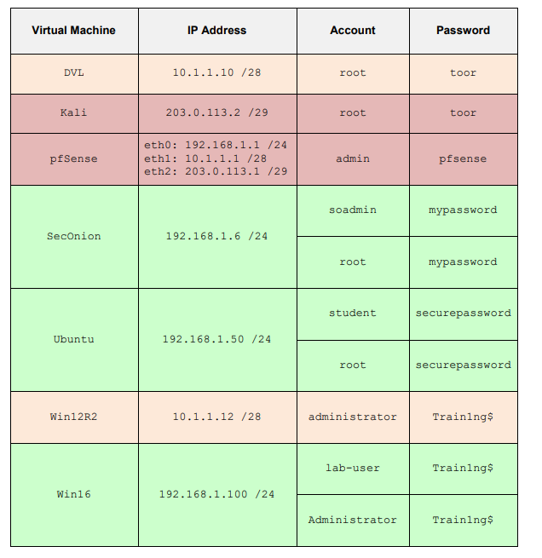
Un-dock the Kali Linux system
  - To undock Kali linux click on the tab with its name in the top right and then click undock
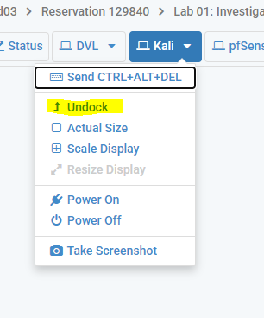
  - After that a separate window will appear like below.
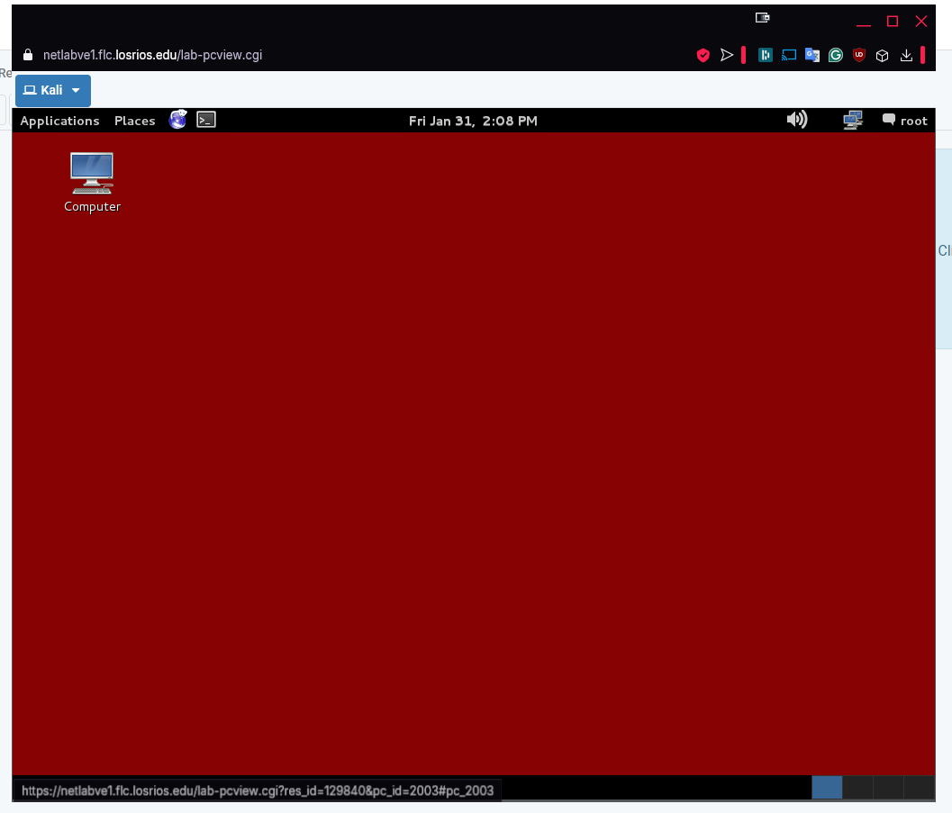
From each system, ping all other systems to ensure that you can reach everything
- To do this you will need to be able to access some form of terminal for most systems in the list excluding DVL and pfSense. Below is how to access the terminal and run a ping command for each system.
  - Kali Linux
    - To open the terminal you can either open the applications tab and select accessories -> Terminal or select the terminal from the top bar to access it directly.
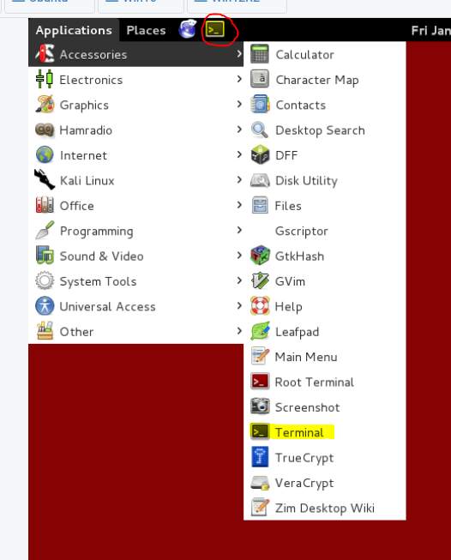
    - To ping a system from the terminal simply type ping [system -c 3 ip] (ping -c 3 10.1.1.10 for example) (-c 3 is used to match the 3 pings that windows does by default)
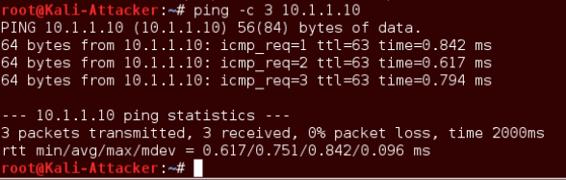
  - SecOnion
    - SecOnion is also a Linux based system to the commands in the terminal are the same but there is a different GUI interface. To access the terminal you can simply click the button in the top left and select the terminal emulator.
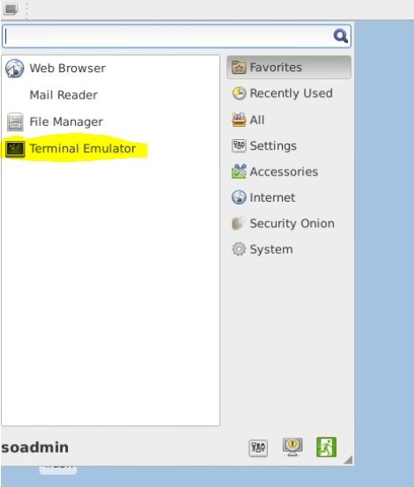
    - To ping a system from the terminal simply type ping [system -c 3 ip] (ping -c 3 10.1.1.10 for example) (-c 3 is used to match the 3 pings that windows does by default)
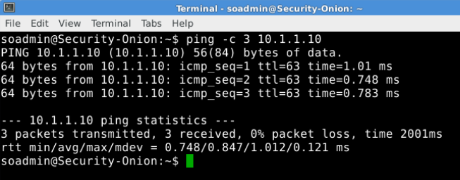
  - Ubuntu
    - Once again we are in a Linux based system to commands will be the same with a different GUI interface. To access the terminal you can either go through Dash Home or click the terminal icon farther down on the left side of the screen.
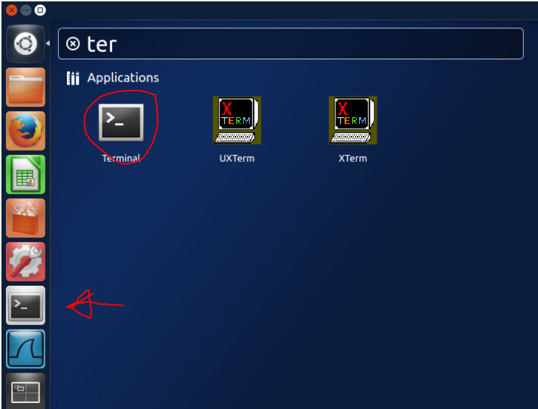
    - To ping a system from the terminal simply type ping [system -c 3 ip] (ping -c 3 10.1.1.10 for example) (-c 3 is used to match the 3 pings that windows does by default)
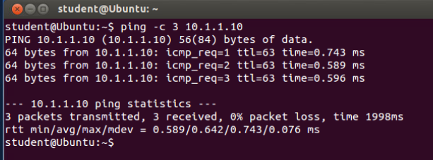
  - WIN16
    - For windows the terminal is called Command Prompt. In this system you have 3 options. Start -> click Command Prompt (as the application is saved in most used), Start and type cmd -> click Command Prompt, start -> Windows System -> Command Prompt.
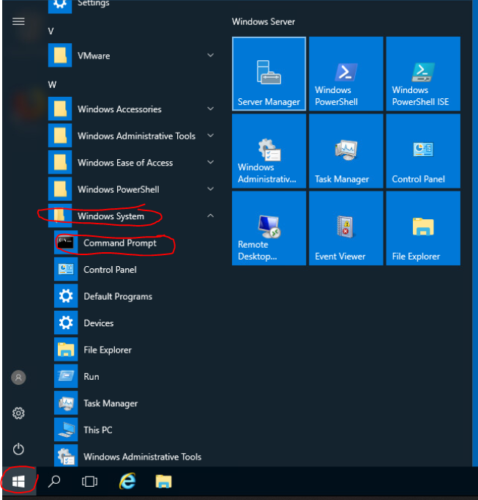
    - With the Command Prompt open type ping [ip address] (ping 10.1.1.10 for example).
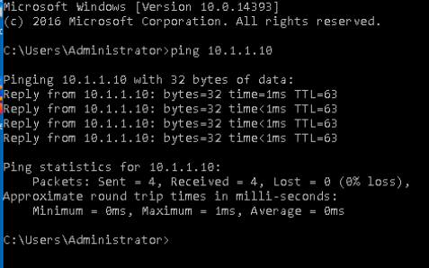
  - Win12R2
    - Due to this being a different version of window server the GUI is slightly different looking but the process is still the same to access the Windows Command Prompt. In this system you have 3 options Start and type cmd -> click Command Prompt, start -> Windows System -> Command Prompt, and lastly clicking the icon in the taskbar.
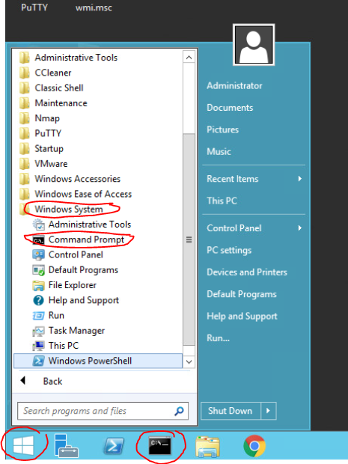
    - With the Command Prompt open type ping [ip address] (ping 10.1.1.10 for example).
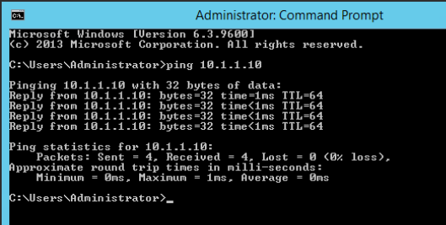
  - DVL
    - For the DVL system it is a command line system so there is no GUI interface. This means that you can login and immediately run a ping command if you would like to. Once again as this is Linux based we can use the command ping -c 3 [IP address] like before.
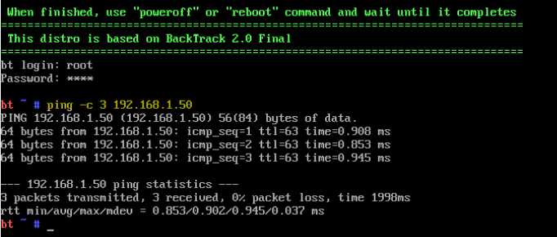
  - pfSense
    - Once again this is a linux based system lacking a GUI interface like the one above. We can use a similar process but we need to select option 7 for ping host then enter [IP address] like before but after we will press enter to return to the first menu. We can then repeat this process for other ping requests
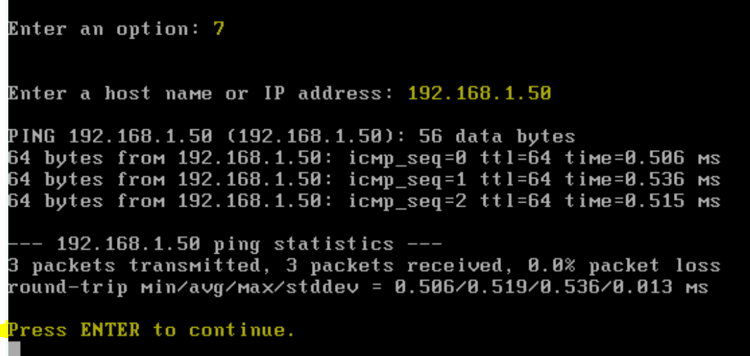

- Below are the results for the pings from each system to all other systems

  - DVL (10.1.1.10)
    - Kali
      - 203.0.113.2 - success
    - pfSense
      - 192.168.1.1 - success
      - 10.1.1.1 - success
      - 203.0.113.1 - success
    - SecOnion
      - 192.168.1.6 - success
    - Ubuntu
      - 192.168.1.50 - success
    - Win12 R2
      - 10.1.1.12 - success
    - Win16
      - 192.168.1.100 - success

  - Kali (203.0.113.2)
    - DVL
      - 10.1.1.10 - success
    - pfSense
      - 192.168.1.1 - success
      - 10.1.1.1 - success
      - 203.0.113.1 - success
    - SecOnion
      - 192.168.1.6 - success
    - Ubuntu
      - 192.168.1.50 - success
    - Win12 R2
      - 10.1.1.12 - success
    - Win16
      - 192.168.1.100 - success

  - pfSense (192.168.1.1 | 10.1.1.1 |203.0.113.1)
    - DVL
      - 10.1.1.10 - success
    - Kali
      - 203.0.113.2 - success
    - SecOnion
      - 192.168.1.6 - success
    - Ubuntu
      - 192.168.1.50 - success
    - Win12 R2
      - 10.1.1.12 - success
    - Win16
      - 192.168.1.100 - success
  - SecOnion (192.168.1.6)
    - DVL
      - 10.1.1.10 - success
    - Kali
      - 203.0.113.2 - success
    - pfSense
      - 192.168.1.1 - success
      - 10.1.1.1 - success
      - 203.0.113.1 - success
    - Ubuntu
      - 192.168.1.50 - success
    - Win12 R2
      - 10.1.1.12 - success
    - Win16
      - 192.168.1.100 - success

  - Ubuntu (192.168.1.50)
    - DVL
      - 10.1.1.10 - success
    - Kali
      - 203.0.113.2 - success
    - pfSense
      - 192.168.1.1 - success
      - 10.1.1.1 - success
      - 203.0.113.1 - success
    - SecOnion
      - 192.168.1.6 - success
    - Win12 R2
      - 10.1.1.12 - success
    - Win16
      - 192.168.1.100 - success

  - Win12R2 (10.1.1.12)
    - DVL
      - 10.1.1.10 - success
    - Kali
      - 203.0.113.2 - success
    - pfSense
      - 192.168.1.1 - success
      - 10.1.1.1 - success
      - 203.0.113.1 - success
    - SecOnion
      - 192.168.1.6 - success
    - Ubuntu
      - 192.168.1.50 - success
    - Win16
      - 192.168.1.100 - success

  - Win16 (192.168.1.100)
    - DVL
      - 10.1.1.10 - success
    - Kali
      - 203.0.113.2 - success
    - pfSense
      - 192.168.1.1 - success
      - 10.1.1.1 - success
      - 203.0.113.1 - success
    - SecOnion
      - 192.168.1.6 - success
    - Ubuntu
      - 192.168.1.50 - success
    - Win12 R2
      - 10.1.1.12 - success

After testing all systems can ping all other systems. This is due to pfSense connecting to all subnets and allowing traffic to freely travel between them rather than segregating / limiting traffic to each subnet.

Part C:
- Access the below files
  - CIS Controls Implementation Guide
Actions
  - NIST Cybersecurity Framework Quick Start
Actions
- These guides serve as the basis for what we will be doing all semester.
  - What is your opinion/view about these documents?
      - CIS-Controls-Guide
        - I like the order of the implementation guide for this document. It goes in the order of:
          - what do we have?
          - Internal security (configurations, existing internal vulnerabilities, user issues with email and web, high level monitoring)
          - External security (infrastructure, attack surface)
          - Then limiting the volume of accounts with access (who NEEDS access)
          - Then account and individual software level monitoring
          - Threat response and security testing. (the point of things should be secure let’s try and poke holes in it)
        - I like this because this order works great for small to medium businesses where they may have never had formal / well documented security before. From this order you clean the internals, secure the outside, then go into reduction of risk / improvement after initial security is established and at the end test and improve after things are “secure”. I’m having trouble putting it into words but this order of operations feels like its built so that there can be clear KPI gathered that can show the “value” of the process to a companies leadership as well as demonstratable milestones and improvement to show improvement.

      - NIST document
        - Without even reading the content, the visuals give me a feeling of a semi technical but high level buy in document (visually interesting, communicating key points in a concise way). Where as the cis-guide has a technical feel with its presentation.
        - I like the summary of each section and the digestibility of the information while providing links to more technical resources related to those areas.
        - The included tables give great resources to create a simple way to track information while being able to grow with the company as it matures in its documentation and security policy.
        - Due to this being aimed at small businesses there is more of an assumed lack of any security policy or practices than the CIS-Guide has some minor security understanding and terminology.

  - We will be working on the top 6 CIS Controls, as well as the NIST framework. Do you think that this is doable for this class? These are high-level guides, so please provide high-level answers.
      - I feel like the volume of the content and the pairing of the controls + framework are doable for this class and are also complementary to each other. One covers specific areas to secure while the other feels more like the flow to follow while securing them.

